A Consolidated List of Links showing Participations/Involvement of faculty Members of the College in various activities:
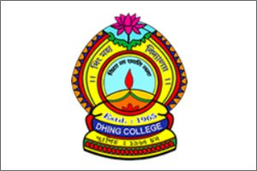
Name & Department | Link in web portal: www.dhingcollege.in
Principal | http://dhingcollege.in/principal/principal_CV.pdf
Assamese | http://dhingcollege.in/department_section.php?dept_id=22
English | http://dhingcollege.in/department_section.php?dept_id=23
Bengali | http://dhingcollege.in/department_section.php?dept_id=24
Economics | http://dhingcollege.in/department_section.php?dept_id=25
Education | http://dhingcollege.in/department_section.php?dept_id=26
Political Science | http://dhingcollege.in/department_section.php?dept_id=27
Geography | http://dhingcollege.in/department_section.php?dept_id=28
History | http://dhingcollege.in/department_section.php?dept_id=29
Physics | http://dhingcollege.in/department_section.php?dept_id=30
Chemistry | http://dhingcollege.in/department_section.php?dept_id=31
Botany | http://dhingcollege.in/department_section.php?dept_id=32
Zoology | http://dhingcollege.in/department_section.php?dept_id=33
Mathematics | http://dhingcollege.in/department_section.php?dept_id=34
Commerce | http://dhingcollege.in/department_section.php?dept_id=35

Certified that the above links are verified by the IQAC Cell and information provided in the links is found correct based on data submitted to IQAC and web portal.
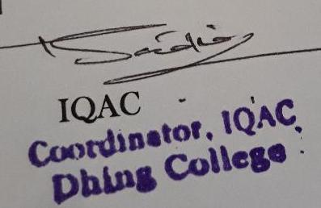

Coordinator,IQAC

